Step 1: Start Selenium Hub:

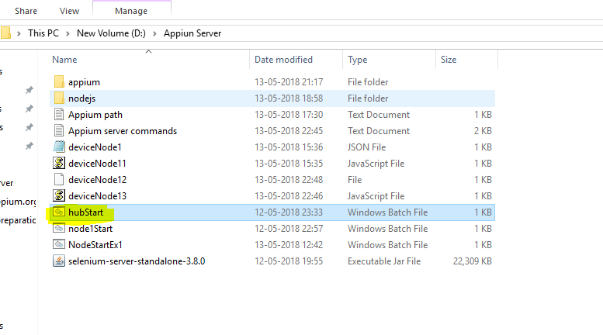

Step 2: Start Appium Server:

Open Appium Server and navigate to Presets tab and start the server. This will be required when scripts are required to run under grid. Under this tab, Node (device is configured ) with appium.

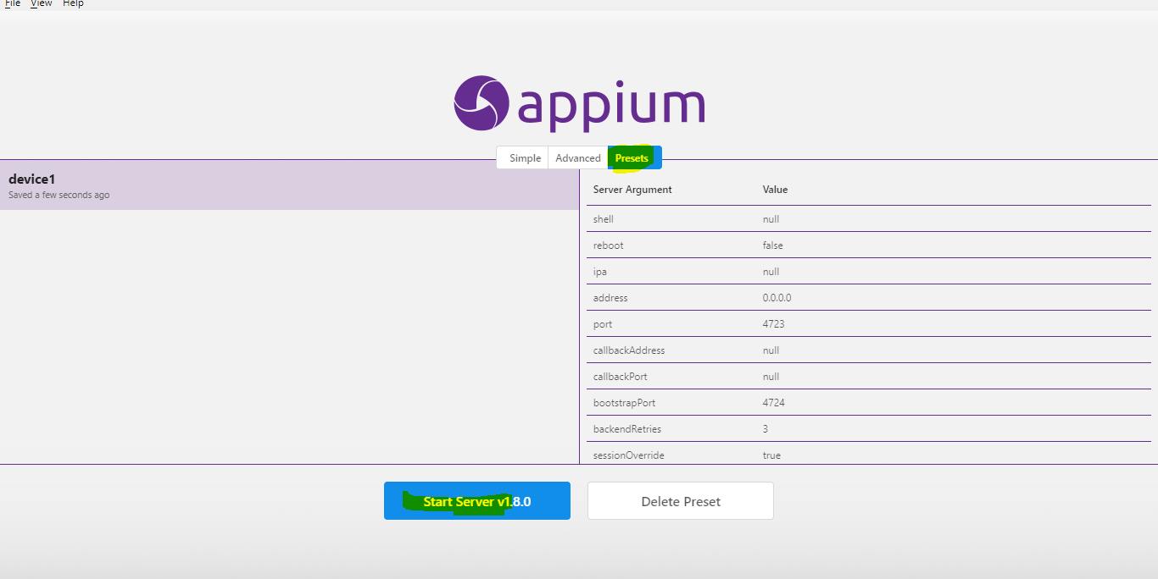

Step 3: Open <http://localhost:4444/grid/console> and check whether the node is configured or not.

